UNIVERSIDAD CATÓLICA DE LA SANTÍSIMA CONCEPCIÓN

FACULTAD DE EDUCACIÓN



ASSESSING TESTS DESIGNS
ASSESSMENT

Teacher:

Gabriela Sanhueza

Student:

Elizabeth Valenzuela

Alejandra Gómez

20/06/2014

INTRODUCTION

This assignment will be focus on the design of one test which it is intended to assess a productive skill. In this case the design will consist of a speaking test.

It is imperative to mention that this test will be developed using Luoma´s (2004) test specifications, in order to back up the creation of the test. Additionally, a rubric will be displayed with the purpose for checking the necessary parameters for the speaking test.

SPEAKING TEST

- List of test specifications from Luoma (2004).

The test´s purpose | To assess student´s domain of units contents at the end of the semester.
Description of the examinees | Eighth Grade School.
Test level | Intermediate level of English
Definitions of construct (theoretical framework for the test) | Students should be able to describe pictures about healthy and unhealthy habits, discuss and agree on health issues and give opinions.
Description of suitable language course of textbook | Students work throughout the semester was based on the textbook “8° básico Travelers” from the Chilean Ministry of education.
Number of sections/papers | This oral test is divided in three sections.  - Describing pictures about healthy and unhealthy habits.  - Getting to an agreement  - Expressing opinions.
Time for each section/paper | Section 1: 2 minutes per test-taker  Section 2: 3 minutes.  Section 3: 2 minutes per test- taker  Total: 12 minutes.
Weighting for each section/paper | Total: 24 points.
Target language situation | - Describing pictures about healthy and unhealthy habits: “I can see” “the unhealthy habit consist of “, “the characteristics are”.  - Getting to an agreement; “Let`s agree that”, “our agreement is”, “I agree with you”, “I think you are right”, “I totally agree with you”.  - Extemporaneous speaking/ expressing opinions “I think that”, “in my opinion”,” I believe that”.
Text types | Images.
Text length | 12 minutes.
Language skills to be tested | Speaking.
Language elements to be tested | - Lexical knowledge (vocabulary)  - The ability to infer meaning from images or context.  - Knowledge about health issues, healthy and unhealthy habits.  - Ability to interact  - Fluency  - Grammar
Test tasks | Describing  Getting to an agreement  Expressing opinions.
Test methods | Instructions
Rubrics | Analytic.
Criteria for marking | - Range of vocabulary  - Comprehension  - Use of grammar  - Fluency  - Interaction  - Subject knowledge

- Additional Information

Warm up activity: Personal Information.

Taking into account the pressure and nervousness that brings a speaking evaluation or test, it is essentially to add a warm-up activity which will be focused on lowering students’ anxiety and fear. The warm- up activity will be based on asking students basic information about them which will not be considered as part of the assessing process.

How are you, today? How was your weekend? What do you do in your free time?

II. Testing task descriptions (Fulcher, n.d)

Task n° 1: Describing pictures about healthy and unhealthy habits.

Student A:
Look at these pictures for a few seconds. Now tell me. What are the healthy and unhealthy habits you can see? Describe the habits represented in the pictures. You have 2 minutes.

Student B:
Look at these pictures for a few seconds. Now tell me. What are the healthy and unhealthy habits you can see? Describe the habits represented in the pictures. You have 2 minutes.
Student B begins.

Task specifications.

Task orientation | Guided through instructions.
Interactional relationship | One way: tester and test taker
Goal orientation | Convergent: Test takers produce a correct description about healthy and unhealthy habits.
Interlocutor status and familiarity | Higher status: tester- test-taker.  Lower status: test-taker- tester.  Low familiarity: tester, test- taker.
Topics | Healthy and unhealthy habits

Task n° 2: Getting to an agreement.

Student A and student B

Look at these pictures for a few seconds. Discuss with your partner partner How might these activities help people escape from pressures of everyday?. You must get to an agreement deciding which of two would have the most lasting benefit.

Task specifications.

Task orientation | Guided through instructions.
Interactional relationship | Two ways: there is interaction between the test takers.
Goal orientation | Convergent: the two test takers must get to an agreement.  Divergent: Test takers elaborate ideas out of stimulus in order to support their choice.
Interlocutor status and familiarity | Same status and high familiarity; test takers interaction.
Topics | Activities to cope with everyday stress

Task n° 3: Giving opinions.

Student A.

Think about the following topics for a few seconds. Public health system in your country, children`s unhealthy habits and teen´s addictions. Choose one of them and speak about for two minutes.

Student B.

Think about the following topics for a few seconds. Public health system in your country, children`s unhealthy habits and teen´s addictions. Choose one of them and speak about for two minutes.

Student A begins.

Task specifications.

Task orientation | Open: Test taker speak freely about a chosen topic.
Interactional relationship | One way: Test taker and tester
Goal orientation | Divergent: Test takers elaborate ideas out of given topic.
Interlocutor status and familiarity | High status: tester, test-taker  Low familiarity: tester, test-taker.
Topics | - Public health system in your country  - Children eating unhealthy eating habits.”  - Teen´s addictions.

III. Scoring procedure: Analytic rubric.

Student´s name: | Grade: | Mark:

Category | Needs improvement(1) | Satisfactory (2) | Good (3) | Excellent (4) | Score
Vocabulary | Inadequate use of vocabulary. | Sometimes use of vocabulary is not adequated. | Adequate and accurate use of vocabulary. | Adequate and accurate use of vocabulary.
Grammar | Student uses a restrictive range of required grammatical structures. | Student uses the grammatical structures correctly but in a limited way. | Student makes a few grammatical mistakes, but she/he tries connecting speech using restricted range of structures. | Student uses a wide range of structures with minor grammatical mistakes.
Comprehension | Student is unable to understand and answer the questions. | Student shows difficulty to understand and answer the question. | Student is able to understand and answer most of the questions. | Student is able to understand and answer all the questions.
Fluency | Speech halting and uneven with long pauses or incomplete thoughts; little sustained speech. | Speech choppy and slow with frequent pauses; few or no incomplete thoughts; some sustained speech. | Speech sustained most of the time; some hesitation but manages to continue and complete thoughts. | Speech sustained most of the time; some hesitation but manages to continue and complete thoughts.
Interaction | Student does not participate in the interaction with his/her classmate. | Student participates poorly in the interaction with his/her classmate | Student participates actively at times with his/her classmate. | Student participates actively when interacting with his/her classmate.
Subject Knowledge | Student shows no knowledge of the unit content. | Student shows a lack of knowledge of the unit content. | Student shows a general knowledge of the unit content. | Student shows a complete knowledge of the unit content.

SCORE: 24 POINTS

Sample papers

English speaking test (June, 2014)

Objective: Assess unit contents at the end of the semester.

I. Task n° 1: Describing pictures about healthy and unhealthy habits.

Student A:

Look at these pictures for a few seconds. Now tell me. What are the healthy and unhealthy habits you can see? Describe the habits represented in the pictures. You have 2 minutes.

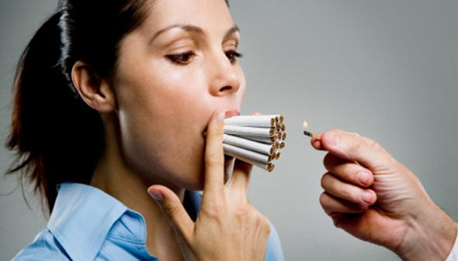

Student B

Look at these pictures for a few seconds. Now tell me. What are the healthy and unhealthy habits you can see? Describe the habits represented in the pictures. You have 2 minutes.

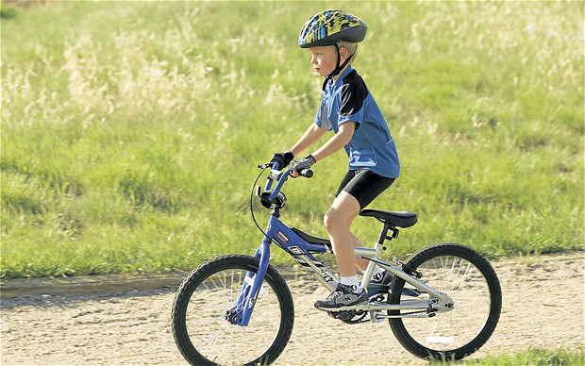

II. Task n°2: Getting to an agreement.


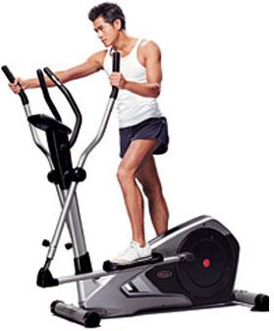

Student A and Student B

Look at these pictures for a few seconds. Discuss with your partner partner How might these activities help people escape from pressures of everyday life?. You must get to an agreement deciding which of two would have the most lasting benefit.

III. Task n°3: Extemporaneous speaking/ giving opinions.

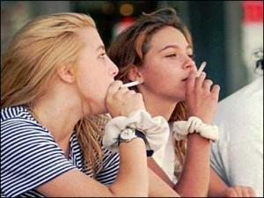
SMOKING MORBID OBESITY


VIDEO GAMES ADDICTION ALCOHOL ADDICTION

Student A and student B

Think about the following topics for a few seconds:

- Public health system in your country
- Children`s unhealthy habits. Teen´s addictions.

- Choose one of them and speak about it for two minutes. Student A begins.

REFERENCE

Fulcher, G. (n.d). Assessing Speaking: putting the pieces together.

Luoma, S. (2004). Assessing Speaking. Cambridge, UK: Cambridge University Press.

